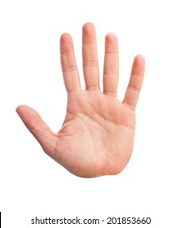

- Must have a way to measure MCP and PIP angles of every finger and thumb.
- Pressure Sensors as Defined by the hand image
- Angles between each finger.
- Get data off glove and synchronized ST.

